Project Charter

PROJECT NAME

Confidential and Proprietary Information
This document contains information that is proprietary to <COMPANY NAME>. Transmittal, receipt, or possession of this document does not express license, or imply rights to use, sell, design, manufacture, or to have manufactured, any product, concept, or service from this information. No reproduction, publication, or disclosure of this information, in whole or in part, electronic or otherwise, shall be made without prior written authorization of an officer of <COMPANY NAME>
Authorized transfer of this document from the custody and control of <COMPANY NAME> constitutes a loan for limited purpose(s), and this document must be returned to <COMPANY NAME> upon request, and in all events, upon completion of the purpose(s) of the loan.

Document Change Log

Prepared By | Title | Date | Version

Revisions

Modified By | Reason | Date | Version

Table of Contents

1. Introduction 4
1.1 General Information 4
2. Project Name 4
3. Client Name 4
4. Decision Makers 4
5. Project Description and Goals 4
6. Business Case 4
7. Key Business Requirements 5
8. Project Objectives 5
9. Benefits 5
10. Target Audience 5
11. The Problem 5
12. The Solution 6
13. Project Scope 6
13.1 In Scope 6
13.2 Out Of Scope 6
14. Pre-requisites 6
15. Assumptions 6
16. Project Constraints 7
17. Project Risks 7
18. Time and Costs 7
19. Project Organization 7
20. Organization Chart 8
21. Project Charter Approval 8

Introduction
[Describe the document and its purpose.]

General Information

Project Name
[The official (and unique) name of the project should be documented to differentiate it from other projects. At many companies, there will be multiple projects in progress at the same time and the project name must differentiate it from other projects. It is common for companies to call their projects by 'codenames" instead of using the actual product name for a project.]

Client Name
[In this section document the legal name of the client( (company, department or individual) along with any acronyms or nicknames that are used to refer to the client. In this section you should also document the names, titles and contact information for each person the client will authorize to be involved with the project in any way. This will include administrative assistant, legal reviewer, accountant, etc., as well as the actual project team members.]

Decision Makers & Steering Committee
[This section will include the names of the project’s decision makers. This will include the project board or steering committee, client representatives, vendor representatives, and any other individuals who have decision making authority for any aspect of the project. You must document the decisions for which each person is responsible including contact information for each person. If you have not identified exactly who the team members will be yet, this list will consist of names and titles for some decision makers and just titles for others. The blanks will be filled in when the Project Plan is created after the project has been approved.]

Stakeholders
[The project stakeholders include everybody that has any involvement or interest in your project. Including all internal and external groups, departments and organizations]

Project Description and Goals
[In this section describe the project in terms that are understandable to everyone on the project team. Avoid the use of technical or industry specific terms whenever possible. Keep the description simple, accurate and unambiguous. Document the high level project goals. These are not the same as the objectives. Goals are high level and may not measurable (broad focus). Objectives are precise, detailed and measurable (narrow focus).]

Business Case
[A business case is typically included in the project concept. If a business case exists, use that as the starting point to document the business case here. It will very likely need some updating now that the project has been better defined. The business case typically includes some historical data about the company, and a description of how things were done in the past and why they need to change. It should include data showing current trends and/or changes in the marketplace, or organization, that make the project necessary.]

Key Business Requirements
[The client will have some very precise requirements regarding what, and how, the project is to be implemented. This section should document those requirements. Ensure that you capture low level and high level requirements. The more you know about what the client specifically wants and does not want, the better positioned you will be to deliver a quality product with high value to the client. Anything that is critical to the business needs of the client should be documented clearly and concisely in this section.]

Project Objectives
[This section should clearly define the objectives of the project including a description of the problem to be addressed and the proposed solution. The objectives define precisely what it is the project must achieve. The objectives must be clear, concise, unambiguous, achievable and, most importantly, measurable. Include a high-level description of how the objectives will be achieved, together with a clear definition of how the success of the project will be measured.]

Benefits
[This section should describe the "value" that the project will bring to the organization. While the business case may have been high level and intangible, the benefits are practical and tangible. The benefits section identifies and describes all the benefits of the project and not just those specific to the business problem that it is addressing. For example, a project to improve customer satisfaction may also have the benefits of increased employee satisfaction and productivity, increased revenue per customer and a decrease in customer support calls.]

Target Audience
[The target audience for your product will be defined by the client. The target audience incorporates anybody and everybody who will be an "end-user" of the product. The exact demographic information required depends on the type of product or service that the project will produce. The definition of the target audience will be influential in both the design and the specification of the project and, as such, it is vital that it is accurate and complete.]

The Problem
[This section clearly and accurately describes the problem, or the problems, that need to be addressed in whole, or in part, as part of this project. It is not necessary for every problem to be solved. It is common for some of the problems identified for a project to be later defined as "out of scope" due to complexity or financial reasons. The problems should still be captured in this section and those items should be listed as specifically out of scope in the scope section of the document. Problems should be described in detail and include examples, where possible, to ensure that the project team fully understands the implications of the problems.]

The Solution
[The solution describes how the problem(s) will be solved. The information contained in this section is the foundation for producing accurate time and cost estimates for the project. Therefore, this information must be comprehensible, unambiguous and very specific. This section should address every problem that has been defined as in scope, so that it is clear exactly how each one will be solved. If there is only one solution that solves all the problems, make sure that it is 100% clear why and how all the problems are addressed.]

Project Scope
[The scope of a project is defined by specified boundaries that separate what is included in the project from what is not included in the project. This section will include the departments, locations, and products that will be involved and included in the project. It also details the phases of the project, which features or functionality will be delivered in each phase of the project, the technical specification, the target audience for the project. The target audience further defines the scope of the project. Any features or functionality that are not required by the target audience will be clearly identified as out of scope.]

In Scope

Out Of Scope

Pre-requisites
[This section should document any specific pre-requisites for the project. This can include third party software or hardware versions that the client has agreed to have installed prior to delivery of the first release, and subsequent releases, of the product. It can also include any testing that the client has agreed to perform on the product. Client testing will usually involve integration testing with their existing systems. Anything that is assumed the client will be providing, or take responsibility for, should be clearly documented in this section.]

Assumptions
[This section of the document defines any assumptions being made about the project, the technology, the project team, roles and responsibilities, etc. It will be understood that all information contained in the project definition document including time and cost estimates, are based on these assumptions. Document any verbal agreements between the client and the project manager. Assumptions may be made about technology compatibility, availability of resources, or the timely completion of assigned tasks or document reviews.]

Project Constraints
[Project constraints are anything that "limits" the project, the project team or the client in anyway. Time, cost, scope, quality, resources and requirements are the most common areas where constraints will be evident.]

Project Risks
[In this section, you identify all known project risks. Risk is the probability that something may happen during or after the development of the project that will have an adverse effect either on the project or the organization.]

Risk | Impact Level (H/M/L) | Risk Plan Actions
1. Project risk 1 |  | Risk plan action 1  Risk plan action 2
2. Project risk 2
3. Project risk 3

Time and Costs
[This section will contain information on the expected timeframe of the project and the associated costs. This is where the initial and detailed estimates that were created during the concept and proposal stages of the project are refined to become detailed estimates. The information contained in the solution section of the document will be used as the basis for the detailed time and cost estimates. Detailed Estimates may be provided in separate documents. In which case, the documents should be referenced here.]

Project Organization
[A well defined and appropriate organizational structure for the proposed project team is essential to the project definition. At this stage it does not have to include specific names but it should include titles (or roles) so that the size of the team is clearly understood.
The organizational structure for the team can be supplied as an organizational chart. The project organization may also include high level information regarding roles and responsibilities for the project. Roles and responsibilities will be described in detail in the project plan.]

Organization Chart
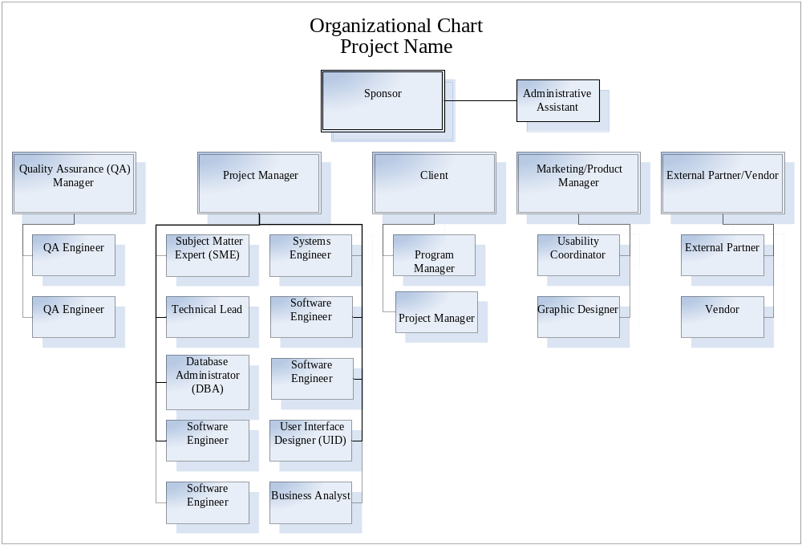

Project Definition Approval
[This section should document the approval process and authorized signatories for the project definition document. The client’s project approval process and timeline should also be contained in this section.]

Client Sponsor:  Sponsor:  Project Manager:
  Signature:
  Print Name:
  Title:
  Date:
  Signature:
  Print Name:
  Title:
  Date:
  Signature:
  Print Name:
  Title:
  Date:

